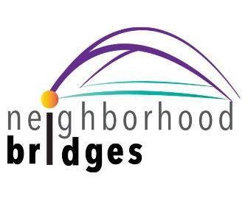

Dear Families:

We are grateful and excited to announce that neighborhood bridges Baldwin County – Eastern Shore is now up and running in our community! Watch this [brief video](https://www.youtube.com/watch?v=mNBXbv_I8Ws&feature=youtu.be) for an overview on how their “Gateway for Kindness” works.

As a 501(c)(3) charity, neighborhood bridges’ mission is: To bridge communities with schools in providing basic needs, removing barriers, and seeking equity for students so they can engage and succeed in school and life.

neighborhood bridges works by inviting our teachers, counselors, social workers and school administrators to become advocates. They receive access to the neighborhood bridges’ platform to post needs on behalf of students and families (who remain anonymous). Needs encompass a wide range of essentials, including school supplies, coats and clothing, help with school or athletic fees, household needs such as beds or groceries, and much more.

Once an advocate posts a need, it is circulated among subscribers (or donors) in the community via a daily email and social media posts. A subscriber wishing to fill a need simply clicks “I can help.” They are then provided with drop-off instructions for the advocate to pick-up the donation and deliver it to the recipient.

Here’s how you can participate:

1. Subscribe to neighborhood bridges Baldwin County – Eastern Shore here: [www.neighborhoodbridges.org/community/baldwincounty-al](http://www.neighborhoodbridges.org/community/baldwincounty-al)
2. Follow neighborhood bridges on Facebook at **facebook.com/nbBaldwinCounty**
3. Respond to needs you’d like to fill by clicking “I can help.” You will receive an automated response with instructions to take your item(s) to a designated drop-off location.
4. We welcome one-time and monthly monetary donations. 100% of your gift will be used to help students and families in need on the Eastern Shore. Donate here: [www.neighborhoodbridges.org/community/baldwincounty-al](http://www.neighborhoodbridges.org/community/baldwincounty-al)
5. neighborhood bridges is here to bridge kindness in the community. If your student/family is in need of essentials and assistance from neighborhood bridges Baldwin County – Eastern Shore, please contact a school counselor or social worker to get started.

Should you have questions, or want more information on the organization, email neighborhood bridges at [baldwincounty@neighborhoodbridges.org](mailto:baldwincounty@neighborhoodbridges.org)

The launch of neighborhood bridges Baldwin County – Eastern Shore gives our team a valuable resource to help meet students’ basic needs and support local families. We encourage you to subscribe to neighborhood bridges, and to reach out if this organization may be of service.

Sincerely,

Andy Burton, Dena Pittman, Lori Terral

Area Directors

neighborhood bridges Baldwin County – Eastern Shore

”*Wherever there is a human being, there is an opportunity for kindness” ~ Lucius Annaeus Seneca*

#KindnessIsCool